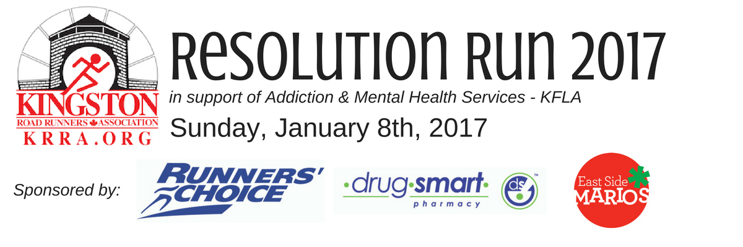
Sunday, January 8th, 2017 | Cataraqui Arena 1030 Sunnyside Road, Kingston
9:00 am Race Registration + Kit Pickup at Cataraqui Arena (Cloverdale Hall)
9:30 am 2km Fun Run/Walk
10:00 am 8km Road Race Starts
11:00 am Awards | Prize Draws | Food

Medals will be awarded to the top 3 runners in KRRA age categories. Course records: Men: 25:05, Women: 27:53.
Great draw prizes for participants, and post-race food provided by East Side Mario’s Restaurant on Weller.
Free parking and washrooms available at the Cataraqui Arena.

Contact Race Director Robin at resolutionrunkingston@gmail.ca for questions or to volunteer

PLEASE COMPLETE THE FOLLOWING FORM FOR EACH PARTICIPANT
RETURN COMPLETED FORMS WITH PAYMENT (CASH OR CHEQUE) TO:
RUNNER’S CHOICE, 56 BROCK STREET KINGSTON
PLEASE MAKE CHEQUES PAYABLE TO: Kingston Road Runners Association (or KRRA)

--------------------------------------------------------------------------------------------------------------------------------------
FIRST NAME ________________________ LAST NAME ________________________
STREET ADDRESS _____________________________________________________
CITY______________________________________ PROV. _______ PC: ____________

E-Mail: ___________________________________ (in case we need to contact you about any changes).
DATE OF BIRTH (mm/dd/yy) _______/_______/________ SEX (CIRCLE ONE): M F
RACE ENTERED (CIRCLE ONE) 8 KM Road Race 2 KM Family Fun Run/Walk

ENTRY FEES:
8km Road Race $40.00 ($35 for KRRA Members)
2km Run/Walk $10 Adults $5 Children (under 12)

PLEASE READ AND SIGN THE PARTICIPATION WAIVER ON BACK

I know that running a road race is potentially hazardous activity, which could cause injury or death. I will not enter and participate unless I am medically able and properly trained, and by my signature, I certify that I am medically able to perform this event, and am in good health, and I am properly trained. I agree to abide by any decision of a race official relative to any aspect of my participation in this event, including the right of any official to deny or suspend my participation for any reason whatsoever. I assume all risks associated with running in this event, including but no limited to: falls, contact with other participants, the effects of the weather, traffic and the conditions of the road, ice, snow and other hazards, with all such risks being known and appreciated by me. I understand that bicycles, skateboards, baby joggers, roller skates or roller blades, animals, and headsets are not allowed in the race and I will abide by this guideline. Having read this waiver ad knowing these facts and inconsideration of your accepting my entry, I, for myself and anyone entitled to act on my behalf, waive and release the KRRA Resolution Run, the city of Kingston, and all sponsors, their representatives and successors from all claims or liabilities of any kind arising out of my participation in this event, even though that liability may arise out of negligence or carelessness on the part of the persons named in this waiver.

Signature (parent/guardian for those under 18) _________________________________________

Date _________________________________________

